OMAGH NORTH

NURSERY SCHOOL

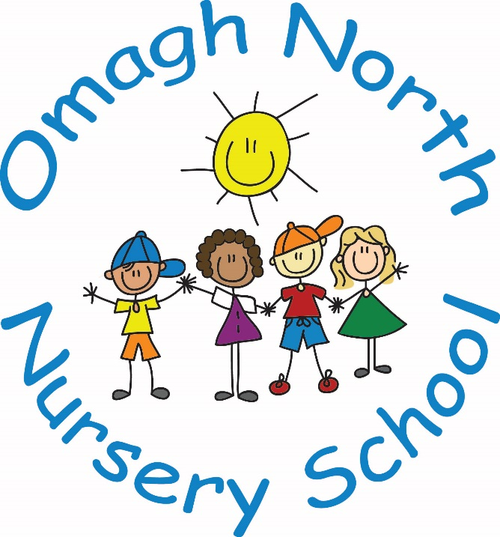

CHILD PROTECTION POLICY

Date ratified by Board of Governors
25/1/11 & amended 20/06/11
Name Change to New Principal on 1st September 2014
Ratified by Board of Governors on 3rd March 2015
Amendments made and ratified by Board of Governors on 9th June 2015
Amendments made and ratified by Board of Governors on 22nd November 2015
Amendments made and ratified by Board of Governors on 22nd November 2016
Amendments made and ratified by Board of Governors on 21st November 2017
Amendments made and ratified by Board of Governors on 19th March 2019
Amendments made and ratified by Board of Governors on 18th June 2019
Amendments made and ratified by Board of Governors on 19th November 2019
Amendments made 17th December 2020 and ratified by Board of Governors on 15th June 2021
Amendments made 17th December 2020 and ratified by Board of Governors on 14th June 2022

Contents
- Our School’s Mission Statement Page 3
- Related Policies Page 3
- The School’s Safeguarding Team Page 4
- Definitions of Harm Page 8
- Responding to a Safeguarding Concern Page 10
- Consent, Confidentiality, Information Sharing and Record Keeping Page 11
- Safe Recruitment Procedures Page 13
- Code of Conduct Page 13
- The Preventative Curriculum Page 13
- Monitoring and Evaluation Page 14
- Appendices:
11.1 Appendix 1 Specific Types of Abuse
11.2 Appendix 2 Children with Increased Vulnerabilities
11.3 Appendix 3 How a Parent Can Make a Complaint
11.4 Appendix 4 Procedure Where the School Has Concerns about Possible Abuse
11.5 Appendix 5 Dealing with Allegations of Abuse against a Member of Staff
11.6 Appendix 6 Note of Concern

Child Protection Ethos
We in Omagh North Nursery School have a responsibility for the safeguarding and child protection of the children in our care and we will carry out this duty by providing a caring, supportive and safe environment, where each child is valued for his or her unique talents and abilities, and in which all our young people can learn and develop to their full potential. All staff, teaching and non-teaching should be alert to the signs of possible abuse and should know the procedures to be followed. This Policy sets out guidance on the action, which is required where abuse or harm to a child is suspected and outlines referral procedures within our school.

Key Principles of Safeguarding and Child Protection

The general principles, which underpin our work, are those set out in the UN Convention on the Rights of the Child and are enshrined in the Children (Northern Ireland) Order 1995, “Co-Operating to Safeguard Children and Young People in Northern Ireland” (DOH, 2017), the Department of Education (Northern Ireland) guidance “Safeguarding and Child Protection in Schools” (DENI Circular 2017/04) and the Safeguarding Board for NI Core Child Protection Policy and Procedures (2017).

The following Principles form the basis of our Child Protection Policy:
- the child or young person’s welfare is paramount;
- the voice of the child or young person should be heard;
- parents are supported to exercise parental responsibility and families helped stay together;
- partnership;
- prevention;
- responses should be proportionate to the circumstances;
- protection; and
- evidence based and informed decision making.
Other Related Policies - these policies should be school specific:
The school has a duty to ensure that safeguarding permeates all activities and functions. The child protection policy therefore complements and supports a range of other school policies including:
- Promotion of Positive Behaviour with anti-bullying statement
- Use of Reasonable Force/Safe Handling
- Special Educational Needs
- Educational Visits
- First Aid and Administration of Medicines
- Health and Safety Policy
- E-Safety Policy
- Toileting and Intimate Care Policy
- GDPR
- Use of Mobile Phones/Cameras
- Whistleblowing policy

These policies are available to parents and any parent wishing to have a copy should contact the School office or visit the school website at www.omaghnorthnursery.org.uk.

School Safeguarding Team

The following are members of the school’s Safeguarding Team:
- Chair of the Board of Governors ( Mr Mervyn Beattie )
- Designated Governor for Child Protection (Mr Roger Johnston)
- Principal / Designated Teacher (Mrs Amanda Duffy-Phillips)
- Deputy Designated Teachers (Mrs Julie Butler and Mrs Pamela McGovern)

Roles and Responsibilities
Designated Teacher/ Deputy Designated Teacher
Every school is required to appoint a Designated Teacher with responsibility for Child Protection. They must also appoint a Deputy Designated Teacher who as a member of the Safeguarding team will actively support the Designated Teacher in carrying out the following duties:
- the induction and training of all school staff including support staff;

- being available to discuss safeguarding or child protection concerns of any member of staff;

- responsibility for record keeping of all child protection concerns;

- maintaining a current awareness of early intervention supports and other local services e.g. Family Support Hubs;

- making referrals to Social Services or PSNI where appropriate;

- liaison with the EA Designated Officers for Child Protection;

- keeping the school Principal informed;
- lead responsibility for the development of the school’s child protection policy;

- promotion of a safeguarding and child protection ethos in the school; and

- compiling written reports to the Board of Governors regarding child protection.

Principal

- as secretary to the Board of Governors, assist in fulfilling its safeguarding and child protection duties;

- ensure the Board of Governors are kept fully informed of all developments relating to safeguarding including changes to legislation, policy, procedures, DE circulars, inclusion of child protection on the termly meeting agenda;

- to manage allegations / complaints against school staff;

- to establish and manage the operational systems for safeguarding and child protection;

- to appoint and manage designated teacher/deputy designated teachers who are enabled to fulfil their safeguarding responsibilities;

- to ensure safe and effective recruitment and selection including awareness of safeguarding and child protection for new staff and volunteers;

- ensure that parents and pupils receive a copy or summary of the child protection policy at intake; and

- to maintain the schools record of child abuse complaints.

Board of Governors

- a designated governor for child protection is appointed;

- a designated and deputy designated teacher are appointed in their schools;

- they have a full understanding of the roles of the designated and deputy designated teachers for child protection;

- safeguarding and child protection training is given to all staff and governors including refresher training;

- the school has a child protection policy which is reviewed annually, and parents and pupils receive a copy of the child protection policy and complaints procedure every year.

- the school has an anti-bullying policy which is reviewed at intervals of no more than four years and maintains a record of all incidents of bullying or alleged bullying. See the Addressing Bullying in Schools Act (NI) 2016;

- there is a code of conduct for all adults working in the school;

- all school staff and volunteers are recruited and vetted, in line with DE Circular 2012/19;

- they receive a full annual report on all child protection matters (It is best practice that they receive a termly report of child protection activities). This report should include details of the preventative curriculum and any initiatives or awareness raising undertaken within the school, including training for staff; and

- the school maintains the following child protection records in line with DE Circulars 2015/13 Dealing with Allegations of Abuse Against a Member of Staff and 2016/20 Child Protection: Record Keeping in Schools.

Chair of Board of Governors

The chair of the board of governors:

- has a pivotal role in creating and maintaining a safeguarding ethos;

- receives training from CPSS and HR;

- assumes lead responsibility in the event of a CP complaint or concern about the principal; and

- ensures compliance with legislation, Child Protection record keeping and policies.

Designated Governor for Child Protection
Advises the board of governors on: -
- the role of the designated teachers;
- the content of child protection policies;
- the content of a code of conduct for adults within the school;
- the content of the termly updates and full annual designated teachers report; and
- recruitment, selection, vetting and induction of staff.
Other members of school staff

- Teachers and Nursery Assistants must refer concerns or disclosures initially to the designated teacher for child protection or to the deputy designated teacher if he/she is not available;

- class teachers should complete the note of concern if there are safeguarding concerns such as: poor attendance and punctuality, poor presentation, changed or unusual behaviour including self-harm and suicidal thoughts, deterioration in educational progress, discussions with parents about concerns relating to their child, concerns about pupil abuse or serious bullying and concerns about home circumstances including disclosures of domestic abuse;

- staff should not give children a guarantee of total confidentiality regarding their disclosures, should not investigate nor should they ask leading questions.

Support Staff

- If any member of the support staff has concerns about a child or staff member they should report these concerns to the designated teacher or deputy designated teacher if he/she is not available. A detailed written record of the concerns will be made and any further necessary action will be taken.

Parents

The primary responsibility for safeguarding and protection of children rests with parents who should feel confident about raising any concerns they have in relation to their child.

Parents can play their part in safeguarding by informing the school:

- if the child has a medical condition or educational need;

- if there are any Court Orders relating to the safety or wellbeing of a parent or child;

- if there is any change in a child’s circumstances for example - change of address, change of contact details, change of name, change of parental responsibility;

- if there are any changes to arrangements about who brings their child to and from school;

- if their child is absent and should send in a note on the child’s return to school. This assures the school that the parent/carer knows about the absence. More information on parental responsibility can be found on the EA website at: www.eani.org.uk/schools/safeguarding-and-child-protection

It is essential that the school has up to date contact details for the parent/carer.

Child Protection Definitions

Definition of Harm

Harm can be suffered by a child or young person by acts of abuse perpetrated upon them by others. Abuse can happen in any family, but children may be more at risk if their parents have problems with drugs, alcohol and mental health, or if they live in a home where domestic abuse happens. Abuse can also occur outside of the family environment. Evidence shows that babies and children with disabilities can be more vulnerable to suffering abuse.

Although the harm from the abuse might take a long time to be recognisable in the child or young person, professionals may be in a position to observe its indicators earlier, for example, in the way that a parent interacts with their child. Effective and ongoing information sharing is key between professionals.

Harm from abuse is not always straightforward to identify and a child or young person may experience more than one type of harm.

Harm can be caused by:
Sexual abuse
Emotional abuse
Physical abuse
Neglect
Exploitation

Sexual Abuse occurs when others use and exploit children sexually for their own gratification or gain or the gratification of others. Sexual abuse may involve physical contact, including assault by penetration (for example, rape, or oral sex) or non-penetrative acts such as masturbation, kissing, rubbing and touching outside clothing. It may include non-contact activities, such as involving children in the production of sexual images, forcing children to look at sexual images or watch sexual activities, encouraging children to behave in sexually inappropriate ways or grooming a child in preparation for abuse (including via e-technology). Sexual abuse is not solely perpetrated by adult males. Women can commit acts of sexual abuse, as can other children.

Emotional Abuse is the persistent emotional maltreatment of a child. It is also sometimes called psychological abuse and it can have severe and persistent adverse effects on a child’s emotional development.

Emotional abuse may involve deliberately telling a child that they are worthless, or unloved and inadequate. It may include not giving a child the opportunity to express their views, deliberately silencing them, or ‘making fun’ of what they say or how they communicate. Emotional abuse may involve bullying – including online bullying through social networks, online games or mobile phones – by a child’s peers.

Physical Abuse is deliberately physically hurting a child. It might take a variety of different forms, including hitting, biting, pinching, shaking, throwing, poisoning, burning or scalding, drowning or suffocating a child.

Neglect is the failure to provide for a child’s basic needs, whether it be adequate food, clothing, hygiene, supervision or shelter that is likely to result in the serious impairment of a child’s health or development. Children who are neglected often also suffer from other types of abuse.

Exploitation is the intentional ill-treatment, manipulation or abuse of power and control over a child or young person; to take selfish or unfair advantage of a child or young person or situation, for personal gain. It may manifest itself in many forms such as child labour, slavery, servitude, and engagement in criminal activity, begging, benefit or other financial fraud or child trafficking. It extends to the recruitment, transportation, transfer, harbouring or receipt of children for the purpose of exploitation. Exploitation can be sexual in nature.

Although ‘exploitation’ is not included in the categories of registration for the Child Protection Register, professionals should recognise that the abuse resulting from or caused by the exploitation of children and young people can be categorised within the existing CPR categories as children who have been exploited will have suffered from physical abuse, neglect, emotional abuse, sexual abuse or a combination of these forms of abuse

Signs and symptoms of abuse – this section can be included as an Appendix in your policy.
Information for schools - Please find attached the link to signs and symptoms from the SBNI Regional Core Policies and Procedures guidance. These need to be customised by your school to reflect the developmental age of your pupils.
https://proceduresonline.com/trixcms/media/1248/signs-and-symptoms-of-child-abuse-and-neglect.pdf.
Specific types of Abuse
In addition to the types of abuse described above there are also some specific types of abuse that we in Omagh North Nursery School are aware of and have therefore included them in our policy. Please see these in Appendix 1.

Children with Increased Vulnerabilities

Some children have increased risk of abuse due to specific vulnerabilities such as disability, lack of fluency in English and sexual orientation. We have included information about children with increased vulnerabilities in our policy. Please see these in Appendix 2

Responding to Safeguarding and Child Protection Concerns

Safeguarding is more than child protection. Safeguarding begins with promotion and preventative activity which enables children and young people to grow up safely and securely in circumstances where their development and wellbeing is not adversely affected. It includes support to families and early intervention to meet the needs of children and continues through to child protection. Child protection refers specifically to the activity that is undertaken to protect individual children or young people who are suffering or are likely to suffer significant harm.

How a Parent can Raise a Concern

In Omagh North Nursery School we aim to work closely with parents/guardians in supporting all aspects of their child’s development and well-being. Any concerns a parent may have will be taken seriously and dealt with in a professional manner.

If a parent has a concern they can talk to the class teacher, the designated or deputy designated teacher for child protection or the principal.

If they are still concerned they may talk to the chair of the board of governors. If after this a parent still has concerns they can contact the NI Public Services Ombudsman.

At any time a parent may talk to a social worker in the local Gateway team or to the PSNI Central Referral Unit. Details of who to contact are shown in the flowchart in Appendix 3.

Where School has concerns or has been given information about possible abuse by someone other than a member of staff

In Omagh North Nursery School if a child makes a disclosure to a teacher or other member of staff which gives rise to concerns about possible abuse, or if a member of staff has concerns about a child, the member of staff will complete a Note of Concern (see Appendix 6) and act promptly. They will not investigate - this is a matter for Social Services - but will discuss these concerns with the designated teacher or with the deputy designated teacher if he/she is not available.

The designated teacher will consult with the principal, or in the absence of the Principal the Education Authority Child Protection Officer or the Designated Governor. If required, advice may be sought from an Education Authority Child Protection Officer. The designated teacher may also seek clarification from the child or young person, their parent/carer.

If a child protection referral is not required the school may consider other options including monitoring, signposting or referring to other support agencies e.g. Family Support Hub with parental consent and, where appropriate, with the child/young person’s consent.

If a child protection referral is required, the designated teacher will seek consent from the parent/carer and/or the child {if they are competent to give this} unless this would place the child at risk of significant harm.

The designated teacher will phone the Gateway team and/or the PSNI and will submit a completed UNOCINI referral form. Where appropriate the source of the concern will be informed of the action taken.

For further detail please see Appendix 4.

Where a complaint has been made about possible abuse by a member of the school’s staff or a Volunteer
When a complaint about possible child abuse is made against a member of staff the Principal (or the designated teacher if the principal is not available) must be informed immediately. If the complaint is against the principal then the deputy designated teacher should be informed and he/she will inform the Chairperson of the board of governors who will consider what action is required in consultation with the employing authority. The procedure as outlined in Appendix 5 will be followed.
Consent
Concerns about the safety or welfare of a child/young person, should, where practicable, be discussed with the parent and consent sought for a referral to children's social services in the local HSC Trust, unless seeking agreement is likely to place the child/young person at further risk through delay or undermine any criminal investigative process (for example in circumstances where there are concerns or suspicions that a crime has taken place); or there is concern raised about the parent's actions or reactions. The communication/language needs of the parents/carers should be established for example in relation to disability/ethnicity and the parent's/carer's capacity to understand should be ascertained. These should be addressed through the provision of appropriate communication methods, including, where necessary, translators, signers, intermediaries or advocacy services.

Effective protection for children/young people may, on occasions, require the sharing of information without prior parental/carer consent in advance of that information being shared.

Where staff decide not to seek parental consent before making a referral to children's social services in the local Health and Social Care Trust or the police, the reason for this decision must be clearly noted in the child/young person's records and included within the verbal and written/UNOCINI referral.

When a referral is deemed to be necessary in the interests of the child/young person, and the parents/carers have been consulted and do not consent, the following action should be taken:
- the reason for proceeding without parental consent must be recorded;
- the withholding of permission by the parent/carer must be included in the verbal and written referral to children's social services;
- the parent/carer should be contacted to inform them that, after considering their wishes, a referral has been made.
Staff making a referral may ask for their anonymity to be protected as far as possible because of a genuine threat to self/family. In such instances this anonymity should be protected with an explanation to the staff member that absolute confidentiality cannot be guaranteed as information may become the subject of court processes.

Confidentiality and Information Sharing

Information given to members of staff about possible child abuse cannot be held “in confidence”. In the interests of the child, staff have a responsibility to share relevant information about the protection of children with other professionals particularly the investigative agencies. In keeping with the principle of confidentiality, the sharing of information with school staff will be on a ‘need to know’ basis.
Where there have been, or are current, child protection concerns about a pupil who transfers to another school we will consider what information should be shared with the Designated Teacher in the receiving school.
Where it is necessary to safeguard children information will be shared with other statutory agencies in accordance with the requirements of this policy, the school data protection policy and the General Data Protection Regulations (GDPR).
Record Keeping
In accordance with DE guidance we must consider and develop clear guidelines for the recording, storage, retention and destruction of both manual and electronic records where they relate to child protection concerns.
To meet these requirements all child protection records, information and confidential notes concerning pupils in our School Name are stored securely and only the Designated Teacher/Deputy Designated Teacher and Principal have access to them. In accordance with DE guidance on the disposal of child protection records these records will be stored from child’s date of birth plus 30 years. If information is held electronically, whether on a laptop or on a portable memory device, all must be encrypted and appropriately password protected.
These notes or records should be factual, objective and include what was seen, said, heard or reported. They should include details of the place and time and who was present and should be given to the Designated/Deputy Designated Teacher. The person who reports the incident must treat the matter in confidence.
Safe Recruitment Procedures
Vetting checks are a key preventative measure in preventing unsuitable individuals’ access to children and vulnerable adults through the education system and schools must ensure that all persons on school property are vetted, inducted and supervised as appropriate. All staff paid or unpaid who are appointed to positions in Omagh North Nursery School are vetted / supervised in accordance with relevant legislation and Departmental guidance.
Code of Conduct For all Staff - Paid or Unpaid
All actions concerning children and young people must uphold the best interests of the young person as a primary consideration. Staff must always be mindful of the fact that they hold a position of trust and that their behaviour towards the child and young people in their charge must be above reproach. All members of staff are expected to comply with the school’s Code of Conduct for Employees and Volunteers which has been approved by the Board of Governors
(See Appendix 7 or the school’s Code of Conduct is available on request)
The Preventative Curriculum

The statutory personal development curriculum requires schools to give specific attention to pupils’ emotional wellbeing, health and safety, relationships, and the development of a moral thinking and value system. The curriculum also offers a medium to explore sensitive issues with children and young people in an age-appropriate way which helps them to develop appropriate protective behaviours. (2017/04)

Our school seeks to promote pupils’ awareness and understanding of safeguarding issues, including those related to child protection through its curriculum. The safeguarding of children is an important focus in the school’s personal social and emotional development programme and is also addressed where it arises within the context of curricular areas. Through the preventative curriculum we aim to build the confidence, self-esteem and personal resiliencies of children so that they can develop coping strategies and can make more positive choices in a range of situations.

Throughout the school year child protection issues are addressed through class discussions and circle time activities and there are permanent child protection posters on display in the cloakroom, classrooms and outdoor areas which provides children with photos of the members of staff they can talk to when feeling sad. Other initiatives which address child protection and safety issues: School visitors e.g. ambulance, etc. health visitor parent programmes, feelings topic.

Operation Encompass
We are an Operation Encompass school. Operation Encompass is an early intervention partnership between local Police and our school, aimed at supporting children who are victims of domestic violence and abuse. As a school, we recognise that children’s exposure to domestic violence is a traumatic event for them.

Children experiencing domestic abuse are negatively impacted by this exposure. Domestic abuse has been identified as an Adverse Childhood Experience and can lead to emotional, physical and psychological harm. Operation Encompass aims to mitigate this harm by enabling the provision of immediate support. This rapid provision of support within the school environment means children are better safeguarded against the short, medium and long-term effects of domestic abuse.

As an Operation Encompass school, when the police have attended a domestic incident and one of our pupils is present, they will make contact with the school at the start of the next working day to share this information with a member of the school safeguarding team. This will allow the school safeguarding team to provide immediate emotional support to this child as well as giving the designated teacher greater insight into any wider safeguarding concerns.

This information will be treated in strict confidence, like any other category of child protection information. It will be processed as per DE Circular 2020/07 ‘Child Protection Record Keeping in Schools’ and a note will be made in the child’s child protection file. The information received on an Operation Encompass call from the Police will only be shared outside of the safeguarding team on a proportionate and need to know basis. All members of the safeguarding team will complete online Operation Encompass training, so they are able to take these calls. Any staff responsible for answering the phone at school will be made aware of Operation Encompass and the need to pass these calls on with urgency to a member of the Safeguarding team.

Further information see The Domestic Abuse Information Sharing with Schools etc. Regulations (Northern Ireland) 2022.

Monitoring and Evaluation
This policy will be reviewed annually by the safeguarding team and approved every year by the Board of Governors for dissemination to parents, pupils and staff. It will be implemented through the school’s staff induction and training programme and as part of day to day practice. Compliance with the policy will be monitored on an on-going basis by the designated teacher for child protection and periodically by the Schools Safeguarding Team. The board of governors will also monitor child protection activity and the implementation of the Safeguarding and Child Protection policy on a regular basis through the provision of reports from the designated teacher.
Date Policy Reviewed: 22nd February 2023
Signed: Mrs Duffy-Phillips (Designated Teacher/Principal)
Mr M Beattie (Chair of Board of Governors)

Appendix 1

Specific Types of Abuse

Grooming of a child or young person is always abusive and/or exploitative. It often involves perpetrator(s) gaining the trust of the child or young person or, in some cases, the trust of the family, friends or community, and/or making an emotional connection with the victim in order to facilitate abuse before the abuse begins. This may involve providing money, gifts, drugs and/or alcohol or more basic needs such as food, accommodation or clothing to develop the child’s/young person’s loyalty to and dependence upon the person(s) doing the grooming. The person(s) carrying out the abuse may differ from those involved in grooming which led to it, although this is not always the case. Grooming is often associated with Child Sexual Exploitation (CSE) but can be a precursor to other forms of abuse. Grooming may occur face to face, online and/or through social media, the latter making it more difficult to detect and identify.
If the staff in Omagh North Nursery School become aware of signs that may indicate grooming they will take early action and follow the school’s child protection policies and procedures.

Child sexual exploitation (CSE) is a form of child sexual abuse. It occurs where an individual or group takes advantage of an imbalance of power to coerce, manipulate or deceive a child or young person under the age of 18 into sexual activity (a) in exchange for something the victim needs or wants, and/ or (b) for the financial advantage or increased status of the perpetrator or facilitator. The victim may have been sexually exploited even if the sexual activity appears consensual. Child sexual exploitation does not always involve physical contact; it can also occur through the use of technology. (Co-operating to Safeguard Children and Young People in NI. DHSSPS version 2.0 2017)
The key factor that distinguishes cases of CSE from other forms of child sexual abuse is the concept of exchange – the fact that someone coerces or manipulates a child into engaging in sexual activity in return for something they need or desire and/or for the gain of those perpetrating or facilitating the abuse. The something received by the child or young person can include both tangible items and/or more intangible ‘rewards’ OR ‘benefits’ such as perceived affection, protection or a sense of value or belonging.
Any child under the age of eighteen, male or female, can be a victim of CSE, including those who can legally consent to have sex. The abuse most frequently impacts upon those of a post-primary age and can be perpetrated by adults or peers, on an individual or group basis.
CSE is a form of child abuse and, as such, any member of staff suspecting that CSE is occurring will follow the school’s child protection policy and procedures, including reporting to the appropriate agencies.
Domestic and Sexual violence and abuse can have a profoundly negative effect on a child’s emotional, psychological and social well-being. A child does not have to witness domestic violence to be adversely affected by it. Living in a violent or abusive domestic environment is harmful to children.
Domestic violence and abuse are defined as ‘threatening, controlling, coercive behaviour, violence or abuse (psychological, virtual, physical, verbal, sexual, financial or emotional) inflicted on anyone (irrespective of age, ethnicity, religion, gender, identity, sexual orientation or any form of disability) by a current or former intimate partner or family member.’ Sexual Violence and Abuse is defined as ‘any behaviour (physical, psychological, verbal, virtual /online perceived to be of a sexual nature which is controlling, coercive, exploitative, harmful or unwanted that is inflicted on anyone (irrespective of age, ethnicity, religion, gender, gender identity, sexual orientation or any form of disability).’ (Stopping Domestic and Sexual Violence and Abuse in Northern Ireland A Seven Year Strategy: March 2016).
If it comes to the attention of school staff that Domestic Abuse, is or may be, affecting a child this will be passed on to the Designated/Deputy Designated Teacher who has an obligation to share the information with the Social Services Gateway Team.

Female Genital Mutilation (FGM) is a form of child abuse and violence against women and girls. FGM comprises all procedures that involve partial or total removal of the external female genitalia, or other injury to the female genital organs for non-medical reasons. The procedure is also referred to as ‘cutting’, ‘female circumcision’ and ‘initiation’. The practice is medically unnecessary, extremely painful and has serious health consequences, both at the time when the mutilation is carried out and in later life. FGM is a form of child abuse and, as such, teachers have a statutory duty to report cases, including suspicion, to the appropriate agencies, through agreed established procedures set out in our school policy.

Forced Marriage A forced marriage is a marriage conducted without the valid consent of one or both parties and where duress is a factor. Duress can include physical, psychological, financial, sexual and emotional pressure. Forced marriage is a criminal offence in Northern Ireland and if in Omagh North Nursery School we have knowledge or suspicion of a forced marriage in relation to a child or young person we will contact the PSNI immediately.
Children who display harmful sexualised behaviour
Learning about sex and sexual behaviour is a normal part of a child’s development. It will help them as they grow up, and as they start to make decisions about relationships. As a school we support children and young people, through the Personal Development element of the curriculum, to develop their understanding of relationships and sexuality and the responsibilities of healthy relationships. Teachers are often therefore in a good position to consider if behaviour is within the normal continuum or otherwise.
It is important to distinguish between different sexual behaviours - these can be defined as ‘healthy’, ‘problematic’ or ‘sexually harmful’. Healthy sexual behaviour will normally have no need for intervention, however consideration may be required as to appropriateness within a school setting. Problematic sexual behaviour requires some level of intervention, depending on the activity and level of concern. For example, a one-off incident may simply require liaising with parents on setting clear direction that the behaviour is unacceptable, explaining boundaries and providing information and education. Alternatively, if the behaviour is considered to be more serious, perhaps because there are a number of aspects of concern, advice from the EA CPSS may be required. We will also take guidance from DE Circular 2016/05 to address concerns about harmful sexualised behaviour displayed by children and young people.

What is Harmful Sexualised Behaviour?
Harmful sexualised behaviour is any behaviour of a sexual nature that takes place when:
- There is no informed consent by the victim; and/or

- the perpetrator uses threat (verbal, physical or emotional) to coerce, threaten or intimidate the victim

- Harmful sexualised behaviour can include: Using age inappropriate sexually explicit words and phrases.
- Inappropriate touching.
- Using sexual violence or threats.

- Sexual behaviour between children is also considered harmful if one of the children is much older - particularly if there is more than two years’ difference in age or if one of the children is pre-pubescent and the other is not.
- However, a younger child can abuse an older child, particularly if they have power over them - for example, if the older child is disabled.

Sexually harmful behaviour is primarily a child protection concern. There may remain issues to be addressed through the school’s positive behaviour policy, but it is important to always apply principles that remain child centred.
Harmful sexualised behaviour will always require intervention and in our school, we will refer to our child protection policy and, seek the support that is available from the CPSS.
E safety/Internet abuse
Online safety means acting and staying safe when using digital technologies. It is wider than simply internet technology and includes electronic communication via text messages, social environments and apps, and using games consoles through any digital device. In all cases, in schools and elsewhere, it is a paramount concern.
In January 2014, the SBNI published its report ‘An exploration of e-safety messages to young people, parents and practitioners in Northern Ireland’ which identified the associated risks around online safety under four categories:
- Content risks: the child or young person is exposed to harmful material.
- Contact risks: the child or young person participates in adult initiated online activity.
- Conduct risks: the child or young person is a perpetrator or victim in peer-to-peer exchange.
- Commercial risks: the child or young person is exposed to inappropriate commercial advertising, marketing schemes or hidden costs.

We in Omagh North Nursery School have a responsibility to ensure that there is a reduced risk of pupils accessing harmful and inappropriate digital content and will be energetic in teaching pupils how to act responsibly and keep themselves safe. As a result, pupils should have a clear understanding of online safety issues and, individually, be able to demonstrate what a positive digital footprint might look like.
The school’s actions and governance of online safety are reflected clearly in our safeguarding arrangements. Safeguarding and promoting pupils’ welfare around digital technology is the responsibility of everyone who comes into contact with the pupils in the school or on school-organised activities.
Sexting is the sending or posting of sexually suggestive images, including nude or semi-nude photographs, via mobile or over the internet. There are two aspects to Sexting:
Sexting between individuals in a relationship schools should look at this individually. Whilst their procedures should be the same as below they may want to include something specific here re what their preventative curriculum approach will be.

Pupils need to be aware that it is illegal, under the Sexual Offences (NI) Order 2008, to take, possess or share ‘indecent images’ of anyone under 18 even if they are the person in the picture (or even if they are aged 16+ and in a consensual relationship) and in these cases we will contact local police on 101 for advice and guidance. We may also seek advice from the EA Child Protection Support Service.

Please be aware that, while offences may technically have been committed by the child/children involved, the matter will be dealt with sensitively and considering all of the circumstances and it is not necessarily the case that they will end up with a criminal record. It is important that particular care is taken in dealing with any such cases. Adopting scare tactics may discourage a young person from seeking help if they feel entrapped by the misuse of a sexual image.
Sharing an inappropriate image with an intent to cause distress
If a pupil has been affected by inappropriate images or links on the internet it is important that it is not forwarded to anyone else. Schools are not required to investigate incidents. It is an offence under the Criminal Justice and Courts Act 2015 (www.legislation.gov.uk/ukpga/2015/2/section/33/enacted) to share an inappropriate image of another person without the individuals consent.
If a young person has shared an inappropriate image of themselves that is now being shared further whether or not it is intended to cause distress, the child protection procedures of the school will be followed.

Appendix 2
Children with Increased Vulnerabilities
- Children with a disability
Children and young people with disabilities (i.e. any child or young person who has a physical, sensory or learning impairment or a significant health condition) may be more vulnerable to abuse and those working with children with disabilities should be aware of any vulnerability factors associated with risk of harm, and any emerging child protection issues.
Staff must be aware that communication difficulties can be hidden or overlooked making disclosure particularly difficult. Staff and volunteers working with children with disabilities will receive training to enable them to identify and refer concerns early in order to allow preventative action to be taken.
- Children with limited fluency in English
As with children with a special educational need, children who are not fluent in English should be given the chance to express themselves to a member of staff or other professional with appropriate language/communication skills, especially where there are concerns that abuse may have occurred.
Designated Teachers should work with their SEN co-ordinators along with school staff with responsibility for newcomer pupils, seeking advice from the EA’s Inclusion and Diversity Service to identify and respond to any particular communication needs that a child may have. All schools should try to create an atmosphere in which pupils with special educational needs which involve communication difficulties, or pupils for whom English is not their first language, feel confident to discuss these issues or other matters that may be worrying them.
- Pre-school provision
Many of the issues in the preceding paragraphs will be relevant to our young children who may have limited communication skills. In addition to the above, staff will follow our Intimate Care policy and procedures in consultation with the child’s parent[s]/carer[s]
- Looked After Children
In consultation with other agencies and professionals, a Health and Social Care Trust may determine that a child or young person’s welfare cannot be safeguarded if they remain at home. In these circumstances, a child may be accommodated through a voluntary arrangement with the persons with parental responsibility for the child or the HSCT may make an application to the Court for a Care Order to place the child or young person in an alternative placement provided by the Trust. The HSCT will then make arrangements for the child to be looked after, either permanently or temporarily. It is important that the views of children, young people and their parents and/or others with parental responsibility for the looked child are taken into account when decisions are made.
A member of school staff will attend LAC meetings and will provide a written report. Where necessary, school support will be put in place for the child/young person. Information will be shared with relevant staff on a need to know basis.
- Children / young people who go missing
Children and young people who go missing come from all backgrounds and communities and are known to be at greater risk of harm. This includes risks of being sexually abused or exploited although children and young people may also become homeless or a victim or perpetrator of crime. Those who go missing from their family home may have no involvement with services as not all children and young people who run away or go missing from their family home have underlying issues within the family or are reported to the police as missing.
The patterns of going missing may include overnight absences or those who have infrequent unauthorised absences of short time duration. When a child or young person returns, having been missing for a period, we should be alert to the possibility that they may have been harmed and to any behaviours or relationships or other indicators that children and young people may have been abused.
School staff will work in partnership with those who look after the child or young person who goes missing and, if appropriate, will complete a risk assessment. Current school policies will apply e.g. attendance, safeguarding, relationships and sexuality education.
- Young people in supported accommodation
Staff will work in partnership with those agencies involved with young people leaving care and those living in supported accommodation and will provide pastoral support as necessary.
- Young people who are homeless
If we become aware that a young person in our school is homeless we will share this information with Social Services, whose role is to carry out a comprehensive needs and risk assessment. We will contribute to the assessment and attend multi-disciplinary meetings.
- Separated, unaccompanied and trafficked children and young people
Separated children and young people are those who have been separated from their parents, or from their previous legal or customary primary caregiver. Unaccompanied children and young people are those seeking asylum without the presence of a legal guardian. Consideration must be given to the fact that separated or unaccompanied children may be a victim of human trafficking.
Child Trafficking is the recruitment, transportation, transfer, harbouring or receipt of a child or young person, whether by force or not, by a third person or group, for the purpose of different types of exploitation.
If we become aware of a child or young person who may be separated, unaccompanied or a victim of human trafficking we in Omagh North Nursery School will immediately follow our safeguarding and child protection procedures
- Children of parents with additional support needs
Children and young people can be affected by the disability of those caring for them. Parents, carers or siblings with disabilities may have additional support needs which impact on the safety and wellbeing of children and young people in the family, possibly affecting their education or physical and emotional development. It is important that any action school staff take to safeguard children and young people at risk of harm in these circumstances encompasses joint working between specialist disability and children’s social workers and other professionals and agencies involved in providing services to adult family members. This will assist us in ensuring the welfare of the children and young people in the family is promoted and they are safeguarded as effectively as possible.
Where it is known or suspected that parents or carers have impaired ability to care for a child, the safeguarding team will give consideration to the need for a child protection response in addition to the provision of family support and intervention.

- Gender identity issues and sexual orientation

Young people from the LGBTQ community may face particular difficulties which could make them more vulnerable to harm. These difficulties could range from intolerance and homophobic bullying from others to difficulties for the young person themselves in exploring and understanding their sexuality. At such times young people may be more vulnerable to predatory advances from adults seeking to exploit or abuse them. This could impede a young person’s ability or willingness to raise concerns if they feel they are at risk or leave young people exposed to contact with people who would exploit them.
As a staff working with young people from the LGBT community we will support them to appropriately access information and support on healthy relationships and to report any concerns or risks of abuse or exploitation.
- Boarding schools and residential settings
Children in the above settings are particularly vulnerable to abuse. We will ensure that staff are appropriately vetted and trained in accordance with DE guidance.
- Work experience, school trips and educational visits
Our duty to safeguard and promote the welfare of children and young people also includes periods when they are in our care outside of the school setting. We will follow DE guidance on educational visits, school trips and work experience to ensure our current safeguarding policies are adhered to and that appropriate staffing levels are in place.

Children/young people’s behaviours

- Peer Abuse
Children and young people may be at risk of physical, sexual and emotional bullying and abuse by their peers. Such abuse should always be taken as seriously as abuse perpetrated by an adult. Where a child or young person has been harmed by another, all school staff should be aware of their responsibilities in relation to both children and young people who perpetrate the abuse as well as those who are victims of it and, where necessary, should contribute to an inter-disciplinary and multi-agency response.
- Self-Harm
Self-harm encompasses a wide range of behaviours and things that people do to themselves in a deliberate and usually hidden way, which are damaging. It may indicate a temporary period of emotional pain or distress, or deeper mental health issues which may result in the development of a progressive pattern of worsening self-harm that may ultimately result in death by misadventure or suicide. Self-harm may involve abuse of substances such as alcohol or drugs, including both illegal and/or prescribed drugs.
Self-harming behaviours may indicate that a child or young person has suffered abuse; however this is not always the case. School staff should share concerns about a child or young person who is self-harming with a member of the safeguarding team who will seek advice from appropriately qualified and experienced professionals including those in the non-statutory sector to make informed assessments of risk in relation to self-harming behaviours.
- Suicidal Ideation
Staff must act without delay if they have concerns about a child or young person who presents as being suicidal as it is important that children and young people who communicate thoughts of suicide or engage in para-suicidal behaviours are seen urgently by an appropriately qualified and experienced professional, including those in the non-statutory sector, to ensure they are taken seriously, treated with empathy, kindness and understanding and informed assessments of risk and needs can be completed as a matter of priority.

PROCEDURE FOR PARENTS WHO WISH TO RAISE A CHILD PROTECTION CONCERN
AT OMAGH NORTH NURSERY

Appendix 3
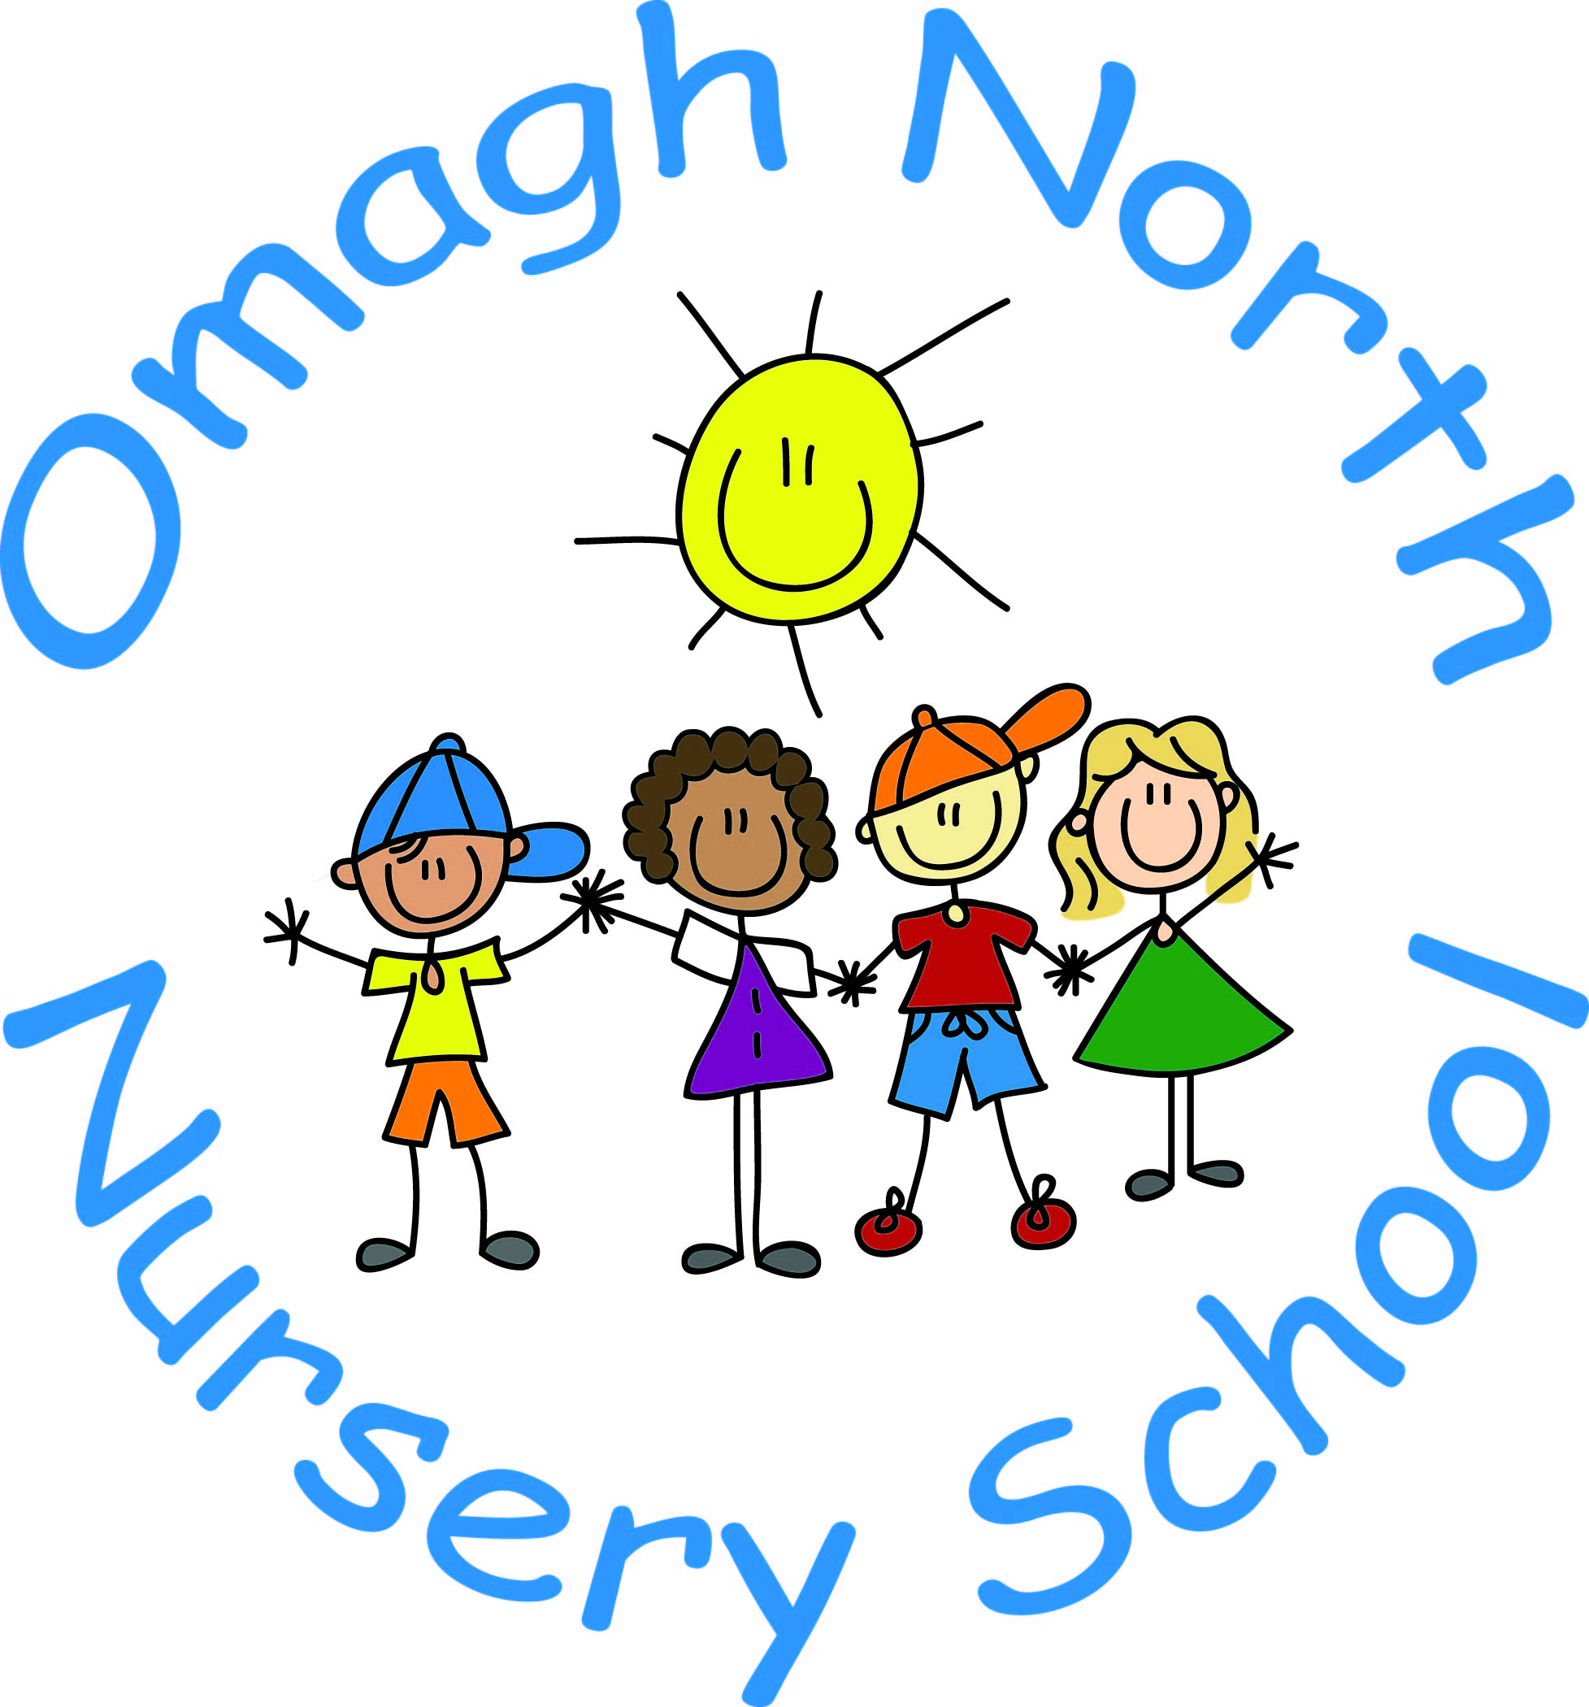

I If I am still concerned, I can talk to or write to the Chairperson of the Board of Governors

If I am still concerned, I can contact the NI Public Services Ombudsman
Tel: 0800 343424

At any time a parent can talk to a social worker at the Gateway Team (Western Trust) Tel: 028 71314 090

or the

PSNI at the Public Protection Unit Central referral unit 02890259299
Tel: 999 (Emergency) or 101 (Non-Urgent)

Appendix 3

Mrs Duffy Phillips
Designated Teacher

I have a concern about my own child or another child’s safety.

I can talk to the class teacher.

If I am still concerned, I can talk to the Designated Teacher, Mrs Duffy-Phillips or the Deputy Designated Teachers, Mrs Butler, Mrs Slane or Miss Mallon.
Omagh North Nursery School’s Telephone Number is 028 82246431

Mrs Butler
Deputy Designated Teacher
Mrs McGovern
Deputy Designated Teacher

I If I am still concerned, I can talk to or write to the Chairperson of the Board of Governors

At anytime a parent can talk to a social worker at the Gateway Team (Western Trust)
Tel: 028 71314 090
Out of Hours Number: 028 9504 9999
or the
PSNI at the Public Protection Unit Central referral unit 02890259299
Tel: 999 (Emergency) or 101 (Non-Urgent)

If I am still concerned, I can contact the NI Public Services Ombudsman
Tel: 0800 343424

Appendix 4

Procedure where the School has concerns, or has been given information, about possible abuse by someone other than a member of staff
Member of staff completes the Note of Concern on what has been observed or shared and must ACT PROMPTLY.
Source of concern is notified that the school will follow up appropriately on the issues raised.

Staff member discusses concerns with the Designated Teacher or Deputy Designated Teacher in his/her absence and provides note of concern.

Designated Teacher should consult with the Principal or other relevant staff before deciding upon action to be taken, always taking care to avoid undue delay. If required, advice may be sought from a CPSS officer.

Where appropriate the source of the concern will be informed as to the action taken. The Designated Teacher will maintain a written record of all decisions and actions taken and ensure that this record is appropriately and securely stored.
Child Protection referral is required
Designated Teacher seeks consent of the parent/carer and/or the child (if they are competent to give this) unless this would place the child at risk of significant harm then telephones the Children’s Services Gateway Team and/or the PSNI if a child is at immediate risk. He/she submits a completed UNOCINI referral form within 24 hours.
Child Protection referral is not required
School may consider other options including monitoring the situation within an agreed timescale; signposting or referring the child/parent/carers to appropriate support services such as the Children’s Services Gateway Team or local Family Support Hub with parental consent, and child/young person’s consent (where appropriate).

Designated Teacher clarifies/discusses concern with child/ parent/carers and decides if a child protection referral is or is not required.

Appendix 5

Dealing with Allegations of Abuse Against a Member of Staff

Key Points
Lead individual learns of an allegation against a member of staff and informs the Chair/Vice Chair of BoG as appropriate.

Guidance on the Next Steps
Lead individual then establishes the facts, seeks advice from the key agencies as appropriate, usually through informal discussion.

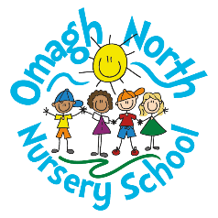
Appendix 6 OMAGH NORTH NURSERY SCHOOL

Possible Outcomes
Following on from establishing the facts, seeking advice from Key Agencies and discussion with the Chair and/or BoG to agree a way forward from the options below.

Alternatives to precautionary suspension imposed

Precautionary suspension under Child Protection procedures imposed

Precautionary suspension is not appropriate and the matter is concluded.

Allegation addressed through relevant disciplinary procedures.
Appendix 6
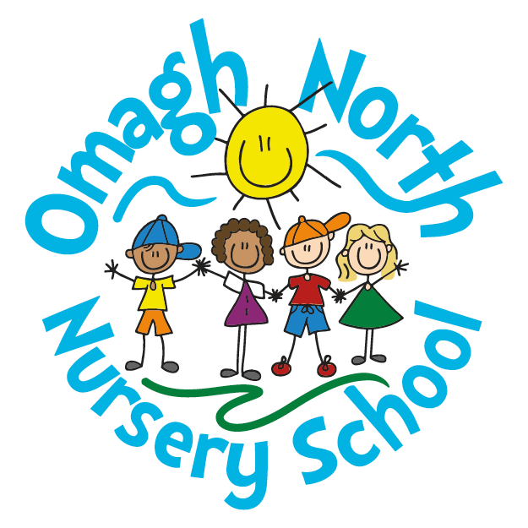
CONFIDENTIAL
Note of Concern
Child Protection Record
Reports to Designated Teacher
(Taking Account of Circular 2016/20 CP Record Keeping in Schools)
Name of Pupil:

Class: AM / FT / PM

Date of Incident/disclosure:

Time of Incident/disclosure:
Circumstances of incident / disclosure:

Nature and description of concern:

Parties involved, including any witnesses to an event and what was said or done and by whom:

Action taken at the time:

Details of advice sought:
From whom:

When:
Any further action taken:

Written report passed to the Designated Teacher: Yes No
If NO, please state the reason:

Date of report to the Designated Teacher:

Time of report to the Designated Teacher:
Written note from staff member placed on pupil’s Child Protection file:
If NO, please state the reason:

Name of staff member making the report: ______________________________
Signature of Staff Member: __________________________ Date: __________
Signature of DT/DDT: ___________________ Date: __________

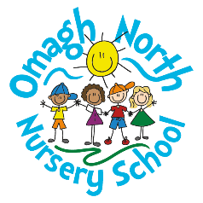
Appendix 7
Omagh North Nursery School’s
Code of Conduct for Staff and Volunteer
(Safeguarding and Child Protection in Schools – A Guide for Schools, 2017)

OBJECTIVE, SCOPE AND PRINCIPLES
This Code of Conduct, which applies to all staff and volunteers, is designed to give guidance on the standards of behaviour which should be observed. School staff and volunteers are role models, in a unique position of influence and trust and their behaviour should set a good example to all the pupils within the school.

It does not form part of any employee’s contract of employment. It is merely for guidance and specific breaches of the Code must not be viewed as a disciplinary offence.

The Code includes sections on:

- Setting an Example
- Relationships and Attitudes
- Private Meetings with Pupils
- Physical Contact with Pupils
- Honesty and Integrity
- Conduct Outside of Work
- E-Safety and Internet Use
- Confidentiality

1. Setting an Example

  - All staff and volunteers in schools set examples of behaviour and conduct which can be copied by pupils. Staff and volunteers should therefore, for example, avoid using inappropriate or offensive language at all times and demonstrate high standards of conduct in order to encourage our pupils to do the same. All staff and volunteers should be familiar with all school policies and procedures and to comply with these so as to set a good example to pupils.

1.2 Staff and volunteers must always comply with statutory requirements in relation to such issues as discrimination, health and safety and data protection.

2. Relationships and Attitudes

2.1 All staff and volunteers should treat pupils with respect and dignity and not in a manner which demeans or undermines them, their parents or carers, or colleagues. Staff and volunteers should ensure that their relationships with pupils are appropriate to the age and maturity of their pupils. They should not demonstrate behaviours that may be perceived as sarcasm, making jokes at the expense of pupils, embarrassing or humiliating pupils, discriminating against or favouring pupils. Attitudes, demeanour and language all require thought to ensure that conduct does not give rise to comment or speculation. Relationships with pupils must be professional at all times and sexual relationships with current pupils are not permitted and may lead to criminal conviction.

2.2 Staff and volunteers may have less formal contact with pupils outside of school; perhaps through mutual membership of social groups, sporting organisations, or family connections. Staff and volunteers should not assume that the school would be aware of any such relationship and should therefore consider whether the school should be made aware of the connection.

2.3 Staff and volunteers should always behave in a professional manner which, within the context of this Code of Conduct, includes such aspects as:

- acting in a fair, courteous and mature manner to pupils, colleagues and other stakeholders;

- cooperating and liaising with colleagues, as appropriate, to ensure pupils receive a coherent and comprehensive educational service;

- respect for school property;

- taking responsibility for the behaviour and conduct of pupils in the classroom and sharing such responsibility elsewhere on the premises;

- being familiar with communication channels and school procedures applicable to both pupils and staff and volunteers;

- respect for the rights and opinions of others.

3. Private Meetings with Pupils

3.1 It is recognised that there will be occasions when confidential interviews with individual pupils must take place. As far as possible, staff and volunteers should conduct interviews in a room with visual access or with an open door and ensure that another adult knows that the interview is taking place. Where possible, another pupil or (preferably) another adult should be present or nearby during the interview.

4. Physical Contact with Pupils

4.1 To avoid misinterpretations, and so far as is practicable, staff and volunteers are advised not to make unnecessary physical contact with a pupil.

4.2 Staff and volunteers should therefore be cognisant of the guidance issued by the Department on the use of reasonable force (Circular 1999/09 and guidance document ‘Towards a Model Policy in Schools on Use of Reasonable Force) and be familiar with the school’s policy on Safe Handling and Use of Reasonable Force.

5. Honesty and Integrity

5.1 All staff and volunteers are expected to maintain the highest standards of honesty and integrity in their work. This includes the handling and claiming of money and the use of school property and facilities.
5.2 Gifts from suppliers or associates of the school (eg a supplier of materials) must be declared to the Principal. A record should be kept of all such gifts received. This requirement does not apply to “one off” token gifts from pupils or parents eg at Christmas or the end of the school year. Staff and volunteers should be mindful that gifts to individual pupils may be considered inappropriate and could be misinterpreted.

6. Conduct Outside of Work

6.1 Staff and volunteers should not engage in conduct outside work which could damage the reputation and standing of the school or the staff/ volunteer’s own reputation or the reputation of other members of the school community.

6.2 Staff and volunteers may undertake work outside school, either paid or voluntary and should ensure it does not affect their work performance in the school. Advice should be sought from the Principal when considering work outside the school.

7. E-Safety and Internet Use

7.1 A staff member or volunteer’s off duty hours are their personal concern but all staff and volunteers should exercise caution when using information technology and be fully aware of the risks to themselves and others. For school-based activities, advice is contained in the school’s E-Safety and Acceptable Use Policy.

7.2 Staff and volunteers should exercise particular caution in relation to making online associations/friendships with current pupils via social media and using texting/email facilities to communicate with them. It is preferable that any contact with pupils is made via the use of school email accounts or telephone equipment when necessary.

7.3 Staff are encouraged not to make links to parents in online platforms. However, if they chose to do so, they must ensure that they follow this policy.

8. Confidentiality

8.1 Staff and volunteers may have access to confidential information about pupils including highly sensitive or private information. It should not be shared with any person other than on a need to know basis. In circumstances where the pupil’s identity does not need to be disclosed the information should be used anonymously.

8.2 There are some circumstances in which a member of staff or volunteer may be expected to share information about a pupil, for example when abuse is alleged or suspected. In such cases, individuals should pass information on without delay, but only to those with designated child protection responsibilities.

8.3 If a member of staff or volunteer is in any doubt about whether to share information or keep it confidential he or she should seek guidance from a senior member of staff. Any media or legal enquiries should be passed to senior leadership.

8.4 Staff and volunteers need to be aware that although it is important to listen to and support pupils, they must not promise confidentiality or request pupils to do the same under any circumstances. Additionally, concerns and allegations about adults should be treated as confidential and passed to the Principal or a member of the safeguarding team without delay.

8.5 The school’s child protection arrangements should include any external candidates studying or sitting examinations in the school.

Co-Operating to Safeguard Children and Young People in Northern Ireland (August 2017) https://www.health-ni.gov.uk/publications/co-operating-safeguard-children-and-young-people-northern-ireland

